45th INTERNATIONAL OCTOBER CONFERENCE
on Mining and Metallurgy

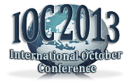  www.ioc.tf.bor.ac.rs  ioc@tf.bor.ac.rs | 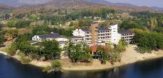  16 – 19 October 2013  Hotel "Jezero"  Bor Lake, Bor, Serbia

REGISTRATION FORM

Name:
Title:
Institution:
Address:
City / Postal Code:
State:
Phone:
Fax:
E-mail:

Paper title:
Authors:

Presentation type: oral
poster

ABSTRACT (not more than 100 words)

Please select the topic of your paper:

Note: Please rename Registration form as follows: ioc45_regform_topic_fullnameoffirstauthor.doc and enclose it in the reply
e-mail with following subject: ioc45_reg_topic_ fullnameoffirstauthor.
If the authors wish to submit more than one paper, please prepare the registration form for each paper.

