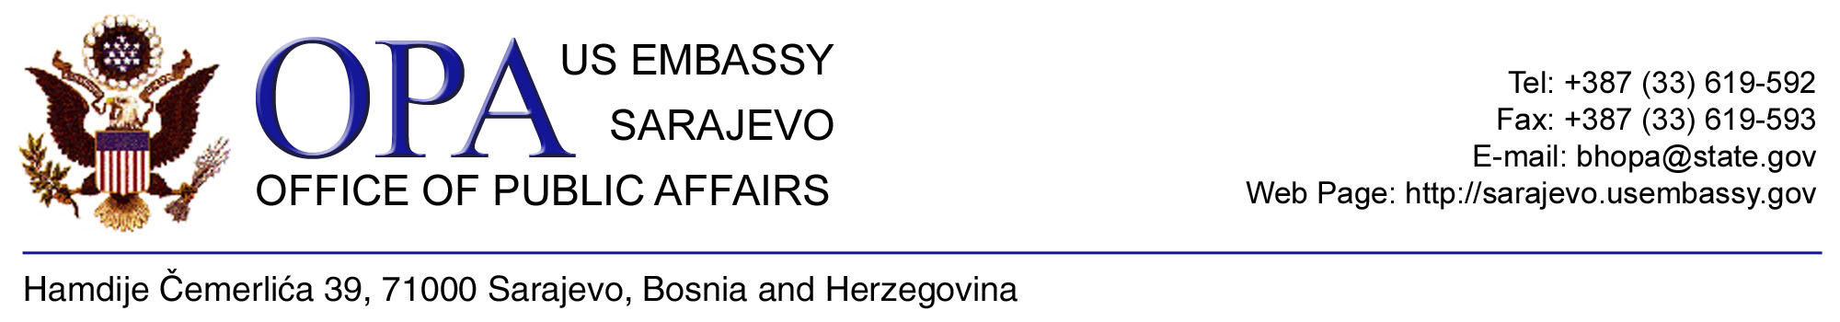

FULBRIGHT STUDENT PROGRAM 2010-2011

The Embassy of the United States of America in Bosnia & Herzegovina is pleased to announce the Fulbright Student Program competition for research in the United States during the 2010-2011 academic year. Scholarships are awarded competitively and are subject to the availability of funds.
The Fulbright Student Program is a non-degree program that brings student researchers to the United States for a nine-month academic year beginning in August or September 2009. The Student Fulbright Program is intended for independent library and/or field research toward a Master's or PhD degree. Students will establish professional contacts in their field, enhance their scholarly work, and gain international experience and personal enrichment.

Academic Fields
Agriculture  American History  American Literature  American Studies  Anthropology  Archaeology  Architecture  Art  Art History  Biological Sciences  Business Administration  Chemistry  Communications  Computer Science  Creative Writing | Dance  Economics  Education  Engineering  Environmental Sciences  Film Studies  Geography  Geology  History (non-US)  Information Sciences  Journalism  Language/Literature (non-US)  Law  Library Science  Linguistics | Mathematics  Medical Sciences  Music  Philosophy  Physics/Astronomy  Political Science  Psychology  Public Administration  Public Health  Religious Studies  Sociology  Social Work  TEFL/Applied Linguistics  Theater  Urban Planning

Eligibility/Requirements:
- BiH Citizenship
- Currently enrolled in a Master's or PhD Program in BiH
- English language proficiency (semi-finalists will be required to take the TOEFL test by January 2010)

Note: Individuals with dual U.S. citizenship or U.S. permanent resident status are ineligible to apply.

Completed applications must include:
- Online application at https://apply.embark.com/student/fulbright/international along with the following supporting documents:
- Detailed research objectives
- Personal statement
- Three letters of reference
- Certified transcripts and diplomas (with certified English translations)
- Professional resume
- Writing sample
Application Deadline: August 1, 2009

For additional information about Fulbright Scholarships:
Email: bhexc@state.gov Website: http://sarajevo.usembassy.gov Tel: 033-619-592

