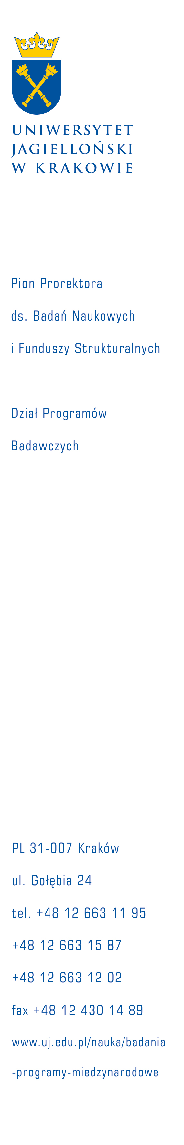

Apply for a Marie Skłodowska-Curie Fellowship at the Jagiellonian University

The Jagiellonian University is seeking to develop collaborative funding proposals with experienced researchers for submission under the Marie Skłodowska-Curie Individual Fellowship (IF) programme within the following thematic areas:

- Cosmic rays (acceleration processes in astrophysical sources and energetic particle propagation) – supervisor: Prof. Michał Ostrowski
- Gamma ray astronomy, applying both space observatories and Cherenkov arrays observatories on Earth surface – supervisor: Prof. Michał Ostrowski
- Investigation of active astrophysical sources, involving X-ray and gamma-ray stellar binaries and active galaxies hosting AGNs – supervisor: Prof. Michał Ostrowski
- Theory of cold atomic/molecular quantum gases. Strongly interacting many-body systems – supervisor: Prof. Jakub Zakrzewski
- Earth paleoenvironmental systems and life evolution – supervisor: Prof. Alfred Uchman
- Organizational leadership, educational leadership, challenges of the contemporary leadership, leaders’ development – supervisor: Associate Prof. Grzegorz Mazurkiewicz
- Normative system in educational organizations, organizational culture of schools, basic values of educational leadership, leadership competencies – supervisor: PhD Roman Dorczak
- Public policy (such as: social policy, social security, public services) – supervisor: PhD Agnieszka Szczudlińska-Kanoś
- Political marketing (such as: modern election campaign at the local, regional, national) - supervisor: PhD Agnieszka Szczudlińska-Kanoś
- Political elites (such as: the functioning of the elites at different levels of government) - supervisor: PhD Agnieszka Szczudlińska-Kanoś
- The role of mechanotransduction processes in cell migration - supervisor: Associate Prof. Zenon Rajfur
- Mathematics: differential equations, nonlinear functional analysis, methods and techniques of nonlinear analysis, calculus of variations, control theory, identification, homogenization, mathematical modeling of physical systems, applications of differential equations to problems of mechanics – supervisor: Prof. Stanisław Migórski.

If you are interested in the above themes, please submit an Expression of Interest (CV and brief description of your research area) by email to: anna.dobranowska@uj.edu.pl

MSCA IFs take the form of European Fellowships and Global Fellowships.
An application must be developed jointly by the researcher and supervisor.

1. European Fellowships involve a single host organisation (future beneficiary) established in an EU Member State or Associated Country. The project proposal is submitted by the host organisation; the proposal is developed by the researcher together with the supervisor. For European Fellowships the applicants can submit their proposals as a Standard Fellowship to one of the 8 main evaluation panels or to one of the 2 multidisciplinary panels: Career Restart Panel (CAR) and Reintegration Panel (RI). The CAR panel provides financial support to individual researchers who want to resume research in Europe after a career break, while the RI panel is dedicated to researchers who want to return to Europe to reintegrate in a longer term research position.
2. Global Fellowships are composed of an outgoing phase during which a researcher spends 1 to 2 years on secondment to a partner organisation in a Third Country, plus a mandatory 12-month return period to a host organisation (the beneficiary) located in a Member State or Associated Country.
For more information go to http://ec.europa.eu/research/participants/portal/desktop/en/opportunities/h2020/calls/h2020-msca-if-2014.html

Experienced Researcher (ER) shall, at the deadline for the submission of the proposal, be in possession of a doctoral degree or have at least four years of full-time equivalent research experience (Guide for Applicants, p.4).

