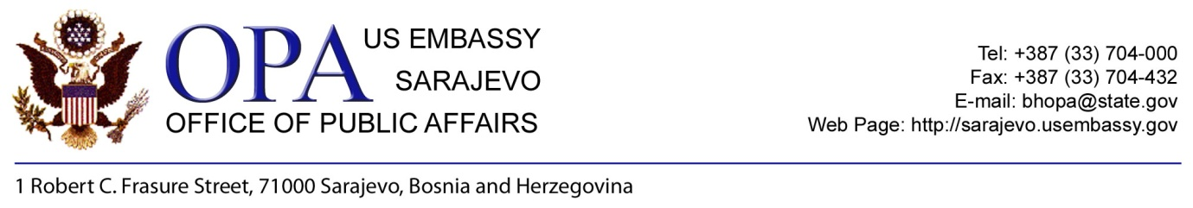
Overview of Exchange Programs Offered
By the Office of Public Affairs, US Embassy Sarajevo
For Academic Year 2014-2015
http://sarajevo.usembassy.gov/educational-exchanges.html

Fulbright Student Program
The Fulbright Student program is a 9 month, non-degree program intended for independent library research and/or field research toward a Master’s or Ph.D. degree. Students will establish professional contacts in their field enhance their scholarly work and gain international experience and personal enrichment. Deadline: June 1, 2013.

Fulbright Visiting Scholar Program
The Fulbright Visiting Scholar program brings scholars to the United States for up to one academic year of professional research with the goal of increasing mutual understanding between the people of the United States and the people of other countries. Candidates must have a Doctoral degree and should be prepared to serve as cultural ambassadors. Deadline: November 1, 2013.

Hubert H. Humphrey Program
This program brings mid-career professionals to the United States for 10 months of academic and professional work. The program offers various combinations of coursework, independent projects, internships, seminars, field trips and consultations with U.S. faculty and experts. Deadline: August 1, 2013.

Study of the United States Institutes for Scholars (SUSI)
The Study of the United States Institutes for Scholars is an intensive post-graduate level academic program with integrated study tours whose purpose is to provide foreign university faculty and other scholars the opportunity to deepen their understanding of American society, culture and institutions. Participants for this program are invited from the Embassy.

Youth Exchange and Study Program (YES)
YES is a high school exchange program which sends 10 high school students to the U.S. for one academic year. Students attend an American high school and live with an American family. YES is a unique way in which young people learn from the American culture and country and at the same time help educate Americans about their culture and country. Deadline: check in August 2013 for testing dates in October with American Councils.

English Teacher Professional Development Distance Learning Program (E-Teacher)
E-Teacher offers English teaching professionals the opportunity to take one of seven innovative, online, graduate level classes through the University of Maryland or the University of Oregon. The courses explore major areas of the academic specialty of Teaching English as a Foreign Language. The 10-week courses are offered in the fall, winter, spring and summer. Deadline: for fall and winter in July, 2013.

For more information contact
Academic Exchange Coordinator, U.S. Embassy Sarajevo
bhexc@state.gov, or phone 033-704-066

